Article type: Full Length/Original Article
Molecular Confirmation and Phylogenetic Analysis of Human BGN and G6PD Gene Fragments Using Sanger Sequencing
Atna Permana1, Prima Nanda Fauziah1, Zuraida1, Parto Fransiskus2
1Bachelor of Applied Medical Laboratory Technology Study Program, Faculty of Health, Universitas Mohammad Husni Thamrin, Jakarta, Indonesia; 2Health Polytechnic of the Ministry of Health Jakarta III, Jakarta, Indonesia
Corresponding Author: Atna Permana
Bachelor of Applied Medical Laboratory Technology Study Program, Faculty of Health, Universitas Mohammad Husni Thamrin, Jakarta, Indonesia; Tel.: +62 819-3120-0083; Fax: Not available; E-mail: atnap@yahoo.com
Running title: Sanger confirmation of BGN and G6PD
DECLARATION
Acknowledgments
The authors thank the laboratory members and technical staff who supported DNA extraction, PCR amplification, Sanger sequencing, sequence assembly, and bioinformatics analysis.
Generative AI and AI-assisted technologies
AI-assisted language tools were used only to improve grammar, clarity, and formatting. They were not used to generate scientific content, perform data analysis, create or manipulate scientific figures, or draw conclusions. The authors reviewed all edited text and take full responsibility for the scientific accuracy, interpretation, originality, and integrity of the manuscript.
Ethical approval
The study protocol was approved by the Ethics Committee of the Faculty of Medicine, Universitas Indonesia-Cipto Mangunkusumo Hospital, Jakarta, Indonesia (ethical code: KET-933/UN2.F1/ETIK/PPM.00.02/2026; protocol number: 26-04-0499; approval date: July 06, 2026). The study was conducted in accordance with the Declaration of Helsinki and applicable national ethical requirements.
Consent to participate
All participants, or their legal guardians where applicable, voluntarily agreed to participate in this research. Written informed consent was obtained before sample collection.
Consent for publication
All authors reviewed the results and approved the final version of the manuscript.
Authors' contributions
AP: conceptualization, methodology, supervision, project administration, original draft preparation, review and editing, and final approval. PNF: data curation, investigation support, review and editing, and final approval. Z: formal analysis support, validation, review and editing, and final approval. PF: investigation, resources, sample and data collection, methodology support, visualization, and final approval.
Data availability
The raw chromatogram files (.ab1), DNA sequence files (.seq), assembled consensus sequences in FASTA format, alignment files, MEGA phylogenetic tree files, and phylogenetic tree figures are available from the corresponding author upon reasonable request. If the consensus sequences are deposited in a public repository during the review process, the accession numbers or repository links will be provided to the journal.
Competing interests
The authors declare that they have no competing interests.
Funding
This research received no specific grant from any funding agency in the public, commercial, or not-for-profit sectors.
Supplementary information
Additional raw chromatogram, sequence, alignment, and phylogenetic tree files may be provided as supplementary material or during review if requested by the editor or reviewers.
Molecular Confirmation and Phylogenetic Analysis of Human BGN and G6PD Gene Fragments Using Sanger Sequencing
ABSTRACT
Background: Targeted molecular confirmation is required when amplified human gene fragments are intended for downstream genetic, biomedical, or population-based studies. This study confirmed human BGN and G6PD gene fragments using PCR, bidirectional Sanger sequencing, and bioinformatics analysis.
Methods: Thirteen anonymized human blood samples were subjected to genomic DNA extraction, PCR amplification of an approximately 700-bp region, agarose gel electrophoresis, bidirectional Sanger sequencing, consensus sequence assembly, BLASTn analysis, multiple sequence alignment, and Neighbor-Joining phylogenetic reconstruction.
Results: All 13 samples yielded genomic DNA suitable for amplification and sequencing. PCR produced a single visible band at the expected size, and bidirectional Sanger sequencing was successful for all samples. BLASTn analysis showed high similarity with human BGN and G6PD reference records, with 99-100% query coverage, 99.64-100% sequence identity, and E-values of 0. Multiple sequence alignment showed high conservation among the analyzed consensus sequences. Phylogenetic analysis supported the placement of the study sequences within human reference sequence groups and showed clustering patterns among the analyzed samples.
Conclusion: The combined PCR-Sanger sequencing-bioinformatics workflow reliably confirmed the amplified human BGN and G6PD gene fragments. The workflow provides a practical basis for preparing targeted sequence data for further genetic and biomedical investigations, while broader clinical or population-level interpretations require larger datasets and additional variant-level analyses.
Keywords: Sequence Analysis, DNA; Molecular Sequence Data; Glucosephosphate Dehydrogenase; Proteoglycans; Phylogeny
1. INTRODUCTION
Accurate molecular confirmation of targeted human gene fragments is an essential step in biomedical research, especially when amplified products will be used for downstream genetic interpretation, sequence validation, or population-based analyses. Although high-throughput sequencing has transformed genomics, Sanger sequencing remains a reliable approach for confirming targeted DNA fragments because it provides direct base-level readout and is widely used for sequence validation [1-5]. In clinical and research settings, Sanger sequencing continues to complement broader sequencing technologies when a specific locus or amplicon requires verification [6,7].
The BGN gene encodes biglycan, a small leucine-rich proteoglycan involved in extracellular matrix organization, tissue remodeling, inflammation, and cell signaling [8-11]. The G6PD gene encodes glucose-6-phosphate dehydrogenase, a key enzyme in the pentose phosphate pathway that protects cells from oxidative stress. Genetic variation affecting G6PD activity is clinically relevant because it is associated with hemolytic anemia and shows population-specific distribution [12-16]. For both genes, reliable molecular confirmation of amplified fragments is important before generated sequence data are used for further biomedical interpretation.
Bioinformatics analysis strengthens targeted sequencing by confirming sequence identity and evolutionary placement. BLAST-based similarity searches are commonly used to compare unknown sequences with nucleotide databases [17,18], whereas multiple sequence alignment and phylogenetic reconstruction help determine whether study sequences are congruent with expected reference sequences [19-25]. These approaches provide complementary evidence for sequence identity, conservation, and phylogenetic placement.
In this study, we applied a combined laboratory and bioinformatics workflow to confirm amplified human BGN and G6PD gene fragments obtained from blood-derived genomic DNA. The workflow integrated PCR specificity assessment, bidirectional Sanger sequencing, consensus sequence assembly, BLASTn identification, multiple sequence alignment, and Neighbor-Joining phylogenetic analysis. The study was designed as a targeted molecular confirmation workflow rather than a clinical variant interpretation or genotype-phenotype association study.
2. MATERIALS AND METHODS
Sample collection and ethical considerations
Thirteen anonymized human blood samples were included in this molecular confirmation study. The samples were coded 511.S.3, 511.S.4, 511.S.6, 511.S.7, 511.S.8, 511.S.9, 511.S.10, 511.S.11, 511.S.12, 511.S.13, 511.S.14, 511.S.15, and 511.S.16; sample code 511.S.5 was not included in the analyzed set. Personal identifiers were not used in the manuscript or sequence analysis. Genomic DNA extracted from the blood samples was used for PCR amplification, Sanger sequencing, and bioinformatics analysis. The study protocol was approved by the Ethics Committee of the Faculty of Medicine, Universitas Indonesia-Cipto Mangunkusumo Hospital, Jakarta, Indonesia (ethical code: KET-933/UN2.F1/ETIK/PPM.00.02/2026; protocol number: 26-04-0499; approval date: July 06, 2026). Written informed consent was obtained from the participants or their legal guardians before sample collection.
DNA extraction
Genomic DNA was isolated from blood samples using the Quick-DNA Miniprep Plus Kit according to the manufacturer's protocol. The DNA concentrations obtained from the 13 samples ranged from 4.51 to 57.97 ng/µL. The extracted DNA was considered sufficient for downstream PCR amplification and Sanger sequencing.
PCR amplification
PCR amplification was performed using the primer pair 4_144_F (5'-TTCAGCCCCATCTTAGCAGC-3') and 4_833_R (5'-GTCCCCAGCCACTTCTAACC-3'), targeting an approximately 700-bp fragment. The thermocycling conditions consisted of initial denaturation at 98 °C for 1 min, followed by 35 cycles of denaturation at 98 °C for 10 s, annealing at 62.3 °C for 5 s, and extension at 68 °C for 18 s, with a final extension at 68 °C for 5 min and a hold step at 4 °C.
Agarose gel electrophoresis
PCR products were separated by agarose gel electrophoresis using a 1-kb DNA ladder to estimate amplicon size. Amplification success and specificity were evaluated based on the presence of a single visible band at the expected fragment size. The gel lane order followed the 13 analyzed sample codes, with lane L representing the 1-kb DNA ladder.
Sanger sequencing and consensus sequence assembly
PCR products were subjected to bidirectional Sanger sequencing using forward and reverse primers and BigDye Terminator v3.0 sequencing chemistry. Sequencing chromatograms were quality-checked, and forward and reverse reads were assembled into consensus sequences using DNA Baser Assembler software. Consensus sequences were used for BLASTn analysis, multiple sequence alignment, and phylogenetic reconstruction.
BLASTn identification
Consensus sequences were compared with entries in the NCBI nucleotide database using BLASTn with the megablast option [17,18]. The top database matches were evaluated according to max score, query coverage, E-value, percentage identity, and accession number. Similarity to human BGN and G6PD reference records was used as evidence supporting molecular confirmation of the amplified gene fragments.
Multiple sequence alignment
Study consensus sequences and selected reference sequences were aligned using the ClustalW algorithm implemented in MEGA software. The alignment was used to evaluate sequence conservation and identify minor nucleotide differences among the analyzed samples [19-22].
Phylogenetic analysis
Phylogenetic trees were reconstructed using the Neighbor-Joining method based on the Tamura-Nei substitution model in MEGA software. Bootstrap analysis was performed to evaluate support for the inferred tree topology [21-25]. Individual sample-reference trees were generated to assess sequence placement relative to selected human BGN and G6PD records, and a composite tree was generated to summarize the relationships among all analyzed samples.
3. RESULTS
DNA quality and PCR amplification
All 13 extracted genomic DNA samples yielded concentrations suitable for PCR amplification and sequencing. DNA concentrations ranged from 4.51 ng/µL in sample 511.S.4 to 57.97 ng/µL in sample 511.S.11. PCR amplification produced a single visible band at the expected approximately 700-bp region in all analyzed samples, supporting successful amplification under the applied PCR conditions (Table 1 and Figure 1).
Sequencing performance
Bidirectional Sanger sequencing was successful for all 13 PCR products. Both forward and reverse reads were reported as normal and successfully sequenced. The resulting reads were assembled into consensus sequences and retained for BLASTn identification, multiple sequence alignment, and phylogenetic reconstruction.
BLASTn-based molecular identification
BLASTn analysis showed that all consensus sequences had high-similarity matches with human BGN and G6PD reference records. Across the analyzed samples, query coverage ranged from 99% to 100%, percentage identity ranged from 99.64% to 100%, and E-values were 0. Representative top-hit accessions included BGN partial sequence records DQ173610.1, DQ173614.1, DQ173592.1, DQ173596.1, and DQ173608.1, as well as G6PD records AY158101.1, ON262108.1, NG_009015.2, AY158129.1, and AY158134.1 (Table 3). These findings support the molecular identity of the amplified human gene fragments.
Multiple sequence alignment
Multiple sequence alignment demonstrated high conservation among the study consensus sequences. Minor nucleotide differences were visible in some samples, but the overall alignment pattern remained consistent across the analyzed set (Figure 2). The alignment results supported the reliability of the generated consensus sequences and were consistent with the high BLASTn similarity values.
Phylogenetic reconstruction
Neighbor-Joining phylogenetic analysis further supported the sequence confirmation results. Individual sample-reference phylogenetic trees placed the study sequences in relation to human BGN and G6PD reference records, whereas the composite tree summarized clustering among all analyzed samples. Bootstrap values in the composite sample tree ranged from 43 to 98, with some paired sample clusters showing higher support, including 511.S.13/511.S.14 and 511.S.6/511.S.12 (Figure 3). The phylogenetic results were consistent with the BLASTn and alignment findings.
4. DISCUSSION
This study showed that a combined laboratory and bioinformatics workflow can confirm amplified human BGN and G6PD gene fragments with high sequence similarity and consistent phylogenetic placement. The availability of PCR, gel electrophoresis, bidirectional Sanger sequencing, BLASTn, alignment, and phylogenetic data strengthens the interpretation that the amplified fragments were suitable for targeted molecular confirmation.
The PCR results showed a single visible band of the expected size in all analyzed samples. This finding supports the specificity of the primer pair under the applied amplification conditions and provides an important quality-control step before sequencing. The successful sequencing of both forward and reverse reads in all samples further indicates that the amplicons were suitable for consensus sequence assembly and downstream analysis [1,2].
The BLASTn results provided the primary sequence-based evidence for molecular identity. All consensus sequences showed high similarity to human BGN and G6PD reference records, with E-values of 0 and identity values between 99.64% and 100%. These results indicate strong agreement between the generated sequences and human reference records in the NCBI nucleotide database. Because BLASTn top-hit interpretation depends on the reference records retrieved, the results should be interpreted as molecular confirmation of the analyzed gene fragments rather than as variant-level clinical classification [17,18].
The multiple sequence alignment supported the reliability of the sequence data by showing a conserved alignment pattern across the samples. This observation is consistent with the targeted nature of the amplified region and with the functional relevance of BGN and G6PD. Biglycan has structural and signaling roles in extracellular matrix biology and inflammatory pathways [8-11], whereas glucose-6-phosphate dehydrogenase is central to cellular redox balance and has well-documented clinical relevance when enzymatic activity is reduced [12-16].
Phylogenetic reconstruction provided an additional validation layer. The individual sample-reference trees positioned the study sequences relative to human BGN and G6PD reference records, and the composite tree showed relationships among the analyzed samples. Although phylogenetic reconstruction is not a substitute for variant interpretation or functional validation, it is useful for demonstrating sequence congruence and checking whether the analyzed sequences behave consistently within a molecular confirmation workflow [21-25].
The main strength of this study is the use of several complementary confirmation steps rather than reliance on a single analytical method. PCR specificity assessment, bidirectional Sanger sequencing, consensus assembly, BLASTn identification, multiple sequence alignment, and phylogenetic reconstruction collectively provide a practical workflow for validating targeted gene fragments before downstream biomedical analyses.
This study also has limitations. The sample size was limited to 13 anonymized blood samples, and the analysis was restricted to targeted gene fragments rather than full-length genes or whole-genome data. Functional assays, enzyme activity measurement, and pathogenicity classification were not performed. Therefore, the findings should not be interpreted as evidence of population-level variation, clinical association, or genotype-phenotype relationship. Future studies should include larger sample sets, public deposition of consensus sequences in appropriate repositories, and integrated variant-level analyses when clinical interpretation is intended [7,26].
5. CONCLUSION
The combined PCR, bidirectional Sanger sequencing, BLASTn, multiple sequence alignment, and phylogenetic reconstruction workflow successfully confirmed amplified human BGN and G6PD gene fragments in 13 anonymized blood samples. The high BLASTn similarity, conserved alignment pattern, successful sequencing performance, and phylogenetic clustering support the molecular identity of the generated sequences. This workflow may be useful for targeted genetic confirmation and for preparing sequence data for subsequent biomedical studies, provided that broader clinical or population-level conclusions are supported by larger datasets and additional variant-level analyses.
REFERENCES
1. Crossley BM, Bai J, Glaser A, Maes R, Porter E, Killian ML, et al. Guidelines for Sanger sequencing and molecular assay monitoring. J Vet Diagn Invest. 2020;32(6):767-775. doi:10.1177/1040638720905833.
2. Mu W, Lu HM, Chen J, Li S, Elliott AM. Sanger validation of high-throughput sequencing in genetic diagnosis: still the best practice? Front Genet. 2020;11:592588. doi:10.3389/fgene.2020.592588.
3. Koboldt DC. Best practices for variant calling in clinical sequencing. Genome Med. 2020;12:91. doi:10.1186/s13073-020-00791-w.
4. Logsdon GA, Vollger MR, Eichler EE. Long-read human genome sequencing and its applications. Nat Rev Genet. 2020;21(10):597-614. doi:10.1038/s41576-020-0236-x.
5. Mantere T, Kersten S, Hoischen A. Long-read sequencing emerging in medical genetics. Front Genet. 2019;10:426. doi:10.3389/fgene.2019.00426.
6. Wenger AM, Peluso P, Rowell WJ, Chang PC, Hall RJ, Concepcion GT, et al. Accurate circular consensus long-read sequencing improves variant detection and assembly of a human genome. Nat Biotechnol. 2019;37(10):1155-1162. doi:10.1038/s41587-019-0217-9.
7. Austin-Tse CA, Jobanputra V, Perry DL, Bick D, Taft RJ, Venner E, et al. Best practices for the interpretation and reporting of clinical whole genome sequencing. NPJ Genom Med. 2022;7(1):27. doi:10.1038/s41525-022-00295-z.
8. Appunni S, Rubens M, Ramamoorthy V, Anand V, Khandelwal M, Sharma A. Biglycan: an emerging small leucine-rich proteoglycan marker and its clinicopathological significance. Mol Cell Biochem. 2021;476(11):3935-3950. doi:10.1007/s11010-021-04216-z.
9. Roedig H, Nastase MV, Wygrecka M, Schaefer L. Breaking down chronic inflammatory diseases: the role of biglycan in promoting a switch between inflammation and autophagy. FEBS J. 2019;286(15):2965-2979. doi:10.1111/febs.14791.
10. Kram V, Shainer R, Jani P, Meester JAN, Loeys B, Young MF. Biglycan in the skeleton. J Histochem Cytochem. 2020;68(10):747-762. doi:10.1369/0022155420937371.
11. Roedig H, Nastase MV, Wygrecka M, Schaefer L. Biglycan is a new high-affinity ligand for CD14 in macrophages. Matrix Biol. 2019;77:4-22. doi:10.1016/j.matbio.2018.05.006.
12. Luzzatto L, Ally M, Notaro R. Glucose-6-phosphate dehydrogenase deficiency. Blood. 2020;136(11):1225-1240. doi:10.1182/blood.2019000944.
13. Tantular IS, Kawamoto F, Matsuoka H, Sumitro SB, Dwi S, et al. Distribution of G6PD deficiency genotypes among Southeast Asian populations. Trop Med Health. 2021;49(1):97. doi:10.1186/s41182-021-00387-z.
14. Chu CS, Bancone G, Nosten F, White NJ, Luzzatto L. Primaquine-induced haemolysis in females heterozygous for G6PD deficiency. Malar J. 2020;19(1):256. doi:10.1186/s12936-020-03303-y.
15. Bancone G, Chu CS. G6PD variants and haemolytic sensitivity to primaquine and other drugs. Front Pharmacol. 2021;12:638885. doi:10.3389/fphar.2021.638885.
16. Lee HY, Ithnin A, Azma RZ, Othman A, Salvador A, Cheah FC. Glucose-6-phosphate dehydrogenase deficiency and neonatal hyperbilirubinemia: insights on pathophysiology, diagnosis, and gene variants in disease heterogeneity. Front Pediatr. 2022;10:875877. doi:10.3389/fped.2022.875877.
17. The NCBI Resource Coordinators. Database resources of the National Center for Biotechnology Information. Nucleic Acids Res. 2024;52(D1):D33-D43. doi:10.1093/nar/gkad1044.
18. Boratyn GM, Thierry-Mieg J, Thierry-Mieg D, Busby B, Madden TL. Magic-BLAST, an accurate RNA-seq aligner for long and short reads. BMC Bioinformatics. 2019;20(1):405. doi:10.1186/s12859-019-2996-x.
19. Edgar RC. Muscle5: high-accuracy alignment ensembles enable unbiased assessments of sequence homology and phylogeny. Nat Commun. 2022;13(1):6968. doi:10.1038/s41467-022-34630-w.
20. Katoh K, Rozewicki J, Yamada KD. MAFFT online service: multiple sequence alignment, interactive sequence choice and visualization. Brief Bioinform. 2019;20(4):1160-1166. doi:10.1093/bib/bbx108.
21. Tamura K, Stecher G, Kumar S. MEGA11: Molecular Evolutionary Genetics Analysis Version 11. Mol Biol Evol. 2021;38(7):3022-3027. doi:10.1093/molbev/msab120.
22. Kumar S, Stecher G, Suleski M, Sanderford M, Sharma S, Tamura K. MEGA12: Molecular Evolutionary Genetic Analysis Version 12 for Adaptive and Green Computing. Mol Biol Evol. 2024;41(12):msae263. doi:10.1093/molbev/msae263.
23. Minh BQ, Schmidt HA, Chernomor O, Schrempf D, Woodhams MD, von Haeseler A, et al. IQ-TREE 2: new models and efficient methods for phylogenetic inference in the genomic era. Mol Biol Evol. 2020;37(5):1530-1534. doi:10.1093/molbev/msaa015.
24. Kozlov AM, Darriba D, Flouri T, Morel B, Stamatakis A. RAxML-NG: a fast, scalable and user-friendly tool for maximum likelihood phylogenetic inference. Bioinformatics. 2019;35(21):4453-4455. doi:10.1093/bioinformatics/btz305.
25. Letunic I, Bork P. Interactive Tree Of Life (iTOL) v5: an online tool for phylogenetic tree display and annotation. Nucleic Acids Res. 2021;49(W1):W293-W296. doi:10.1093/nar/gkab301.
26. Sayers EW, Cavanaugh M, Clark K, Ostell J, Pruitt KD, Karsch-Mizrachi I. GenBank. Nucleic Acids Res. 2020;48(D1):D84-D86. doi:10.1093/nar/gkz956.

FIGURES AND TABLES
Table 1. DNA extraction results
No. | Sample code | DNA concentration (ng/µL)
1 | 511.S.3 | 5.02
2 | 511.S.4 | 4.51
3 | 511.S.6 | 5.33
4 | 511.S.7 | 6.77
5 | 511.S.8 | 5.28
6 | 511.S.9 | 12.87
7 | 511.S.10 | 7.57
8 | 511.S.11 | 57.97
9 | 511.S.12 | 13.81
10 | 511.S.13 | 10.61
11 | 511.S.14 | 15.98
12 | 511.S.15 | 11.54
13 | 511.S.16 | 7.65
Table 2. Primer information and PCR profile
Component | Parameter | Sequence/condition | Product size/cycles
Primer | 4_144_F | TTC AGC CCC ATC TTA GCA GC | ~700 bp
Primer | 4_833_R | GTC CCC AGC CAC TTC TAA CC | ~700 bp
PCR | Initial denaturation | 98 °C, 1 min | 1 cycle
PCR | Denaturation | 98 °C, 10 s | 35 cycles
PCR | Annealing | 62.3 °C, 5 s | 35 cycles
PCR | Extension | 68 °C, 18 s | 35 cycles
PCR | Final extension | 68 °C, 5 min | 1 cycle
PCR | Hold | 4 °C | -
Table 3. Summary of BLASTn confirmation results for analyzed samples
Sample code | Max score | Query coverage | Identity (%) | E-value | Representative BGN accession | Representative G6PD accession
511.S.3 | 1027 | 99% | 99.64 | 0 | DQ173610.1 | AY158101.1
511.S.4 | 1033 | 100% | 100 | 0 | DQ173610.1 | AY158101.1
511.S.6 | 1037 | 100% | 100 | 0 | DQ173610.1 | AY158101.1
511.S.7 | 1031 | 100% | 100 | 0 | DQ173610.1 | AY158101.1
511.S.8 | 1037 | 100% | 100 | 0 | DQ173610.1 | AY158101.1
511.S.9 | 1011 | 99-100% | 100 | 0 | DQ173610.1 | AY158101.1
511.S.10 | 1011 | 100% | 100 | 0 | DQ173610.1 | AY158101.1
511.S.11 | 1037 | 100% | 99.82 | 0 | DQ173610.1 | AY158101.1
511.S.12 | 1055 | 100% | 99.83 | 0 | DQ173610.1 | AY158101.1
511.S.13 | 1044 | 99% | 99.65 | 0 | DQ173610.1 | AY158101.1
511.S.14 | 1044 | 99% | 99.65 | 0 | DQ173610.1 | AY158101.1
511.S.15 | 1031 | 100% | 100 | 0 | DQ173610.1 | AY158101.1
511.S.16 | 1221 | 100% | 100 | 0 | DQ173610.1 | AY158101.1
Note: Representative accessions are shown from the BLASTn top-hit set. Other recurrent human BGN records included DQ173614.1, DQ173592.1, DQ173596.1, and DQ173608.1; other recurrent human G6PD records included ON262108.1, NG_009015.2, AY158129.1, and AY158134.1.
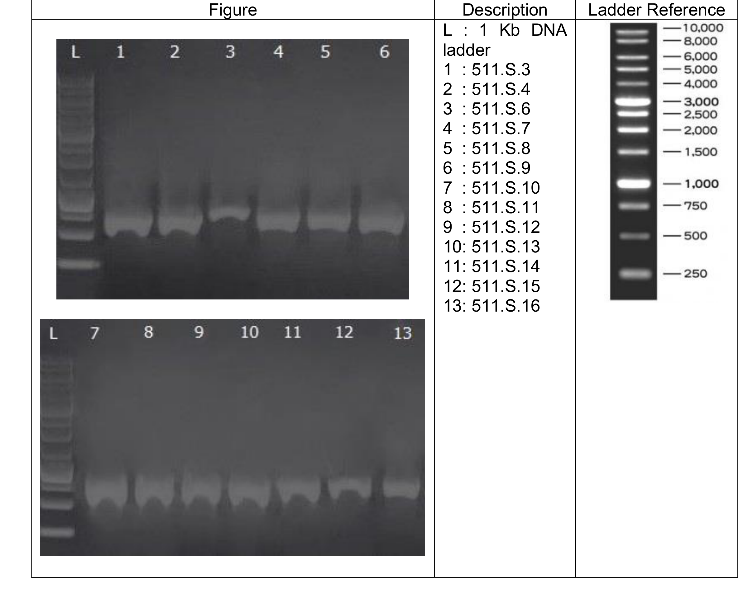
Figure 1. Agarose gel electrophoresis of PCR-amplified fragments from the 13 analyzed samples. L indicates the 1-kb DNA ladder. Lanes 1-13 correspond to samples 511.S.3, 511.S.4, 511.S.6, 511.S.7, 511.S.8, 511.S.9, 511.S.10, 511.S.11, 511.S.12, 511.S.13, 511.S.14, 511.S.15, and 511.S.16.
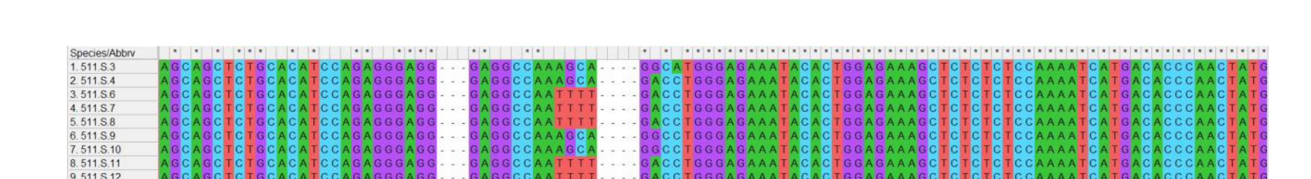
Figure 2. Multiple sequence alignment of consensus sequences from the 13 analyzed samples.
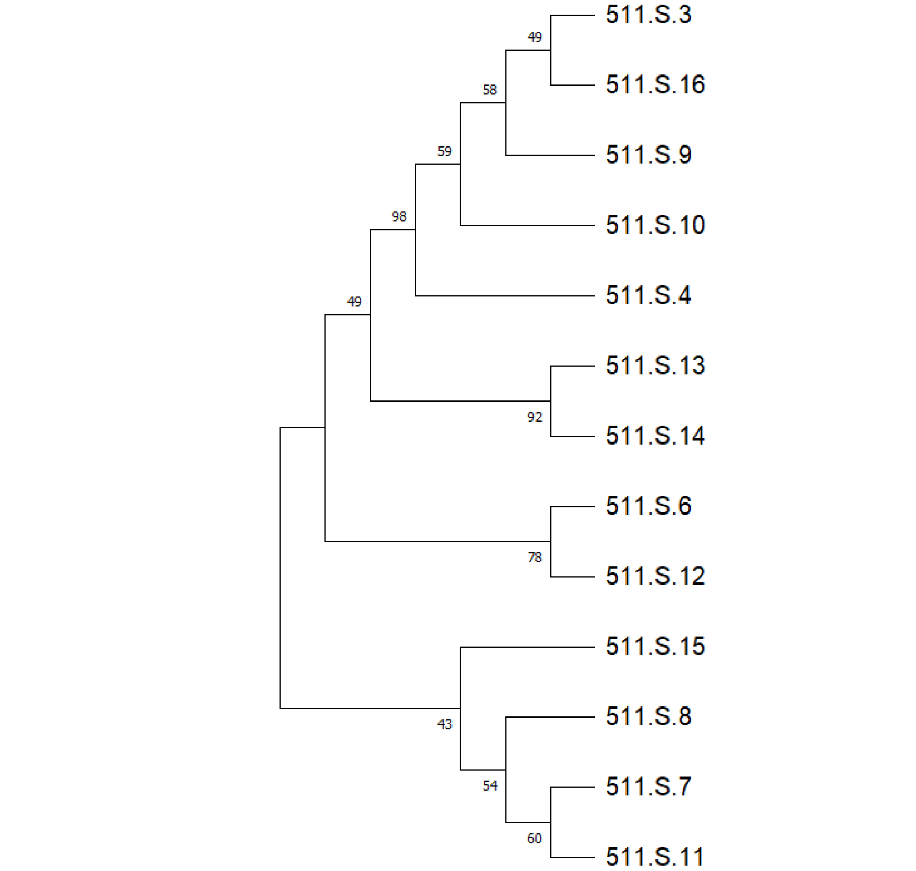
Figure 3. Neighbor-Joining phylogenetic tree summarizing the relationships among all analyzed sample consensus sequences. Bootstrap values are shown at the nodes.

